MOUNT CARMEL SCHOOL, BHUNGA
ICSE TOPPERS 2020-2021

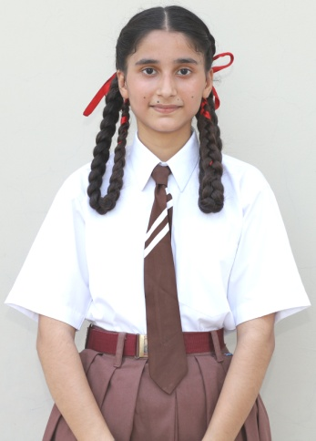
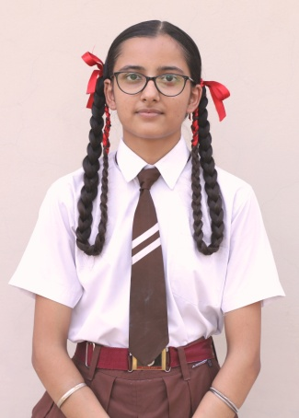
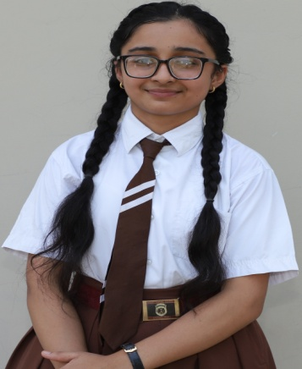

NAVROOP KAUR BAHULPREET KAUR MEHAKPREET
D/o MR. SUKHPREET SINGH D/o MR. SARBJIT SINGH D/o MR. MOHAN SINGH
98.4 % 97.8 % 97.6%

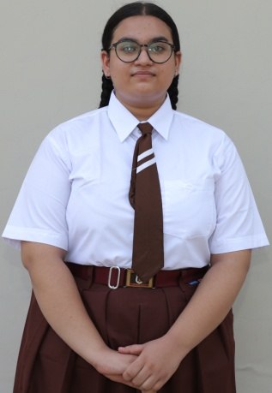
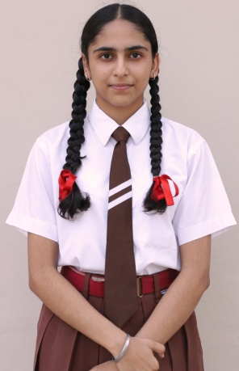
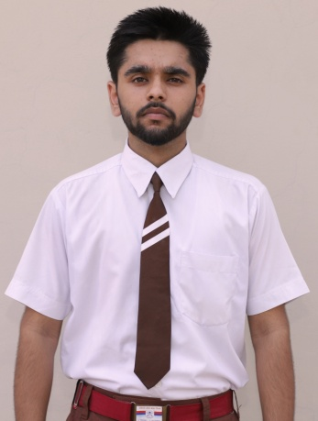

SACHIN SAMANPREET KAUR ASMITA SHARMA
S/o MR. HIRA NAND LAL D/o MR. PAKHAR SINGH D/o MR. SANDEEP KUMAR
97.6% 96.8% 95.8%

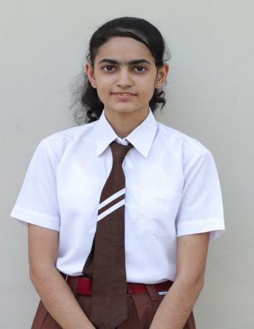
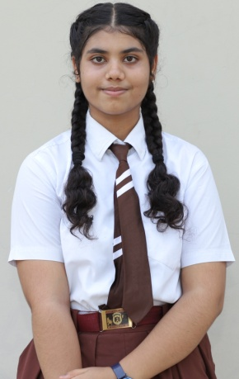

ARSHDEEP KAUR SUKRITI SETH
D/o MR. HARDYAL SINGH D/o MR. SANJEEV SETH
95.2% 95.2%

